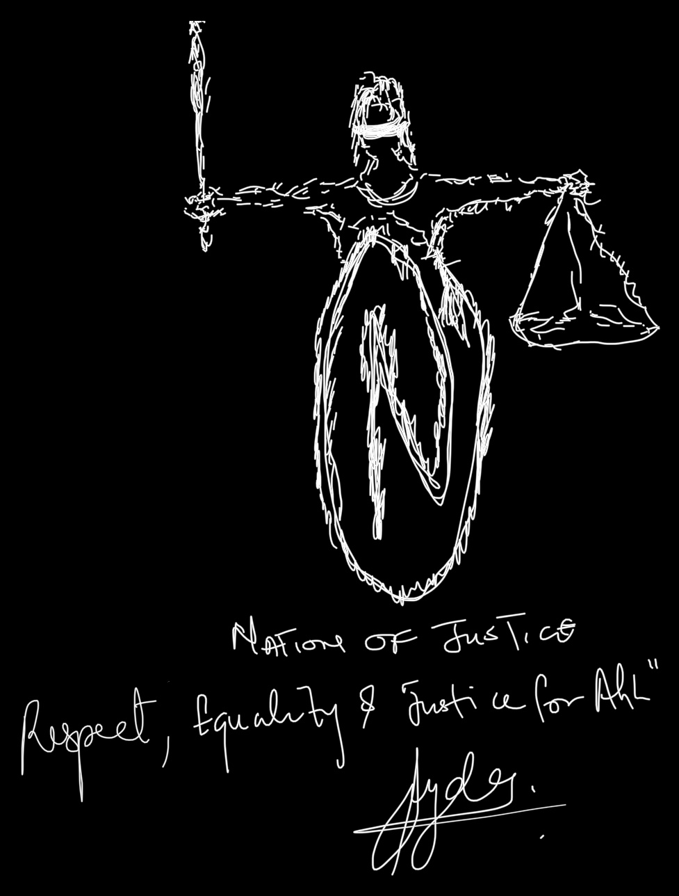

MY ADDRESS
TO SOUTH AFRICAN YOUTHS
⬥ NATION OF JUSTICE ⬥
Respect • Equality • Justice for All
⬥ ⬥ ⬥

DEMOCRACY IS NOT ONE-SIZE-FITS-ALL
The Real Revolution Starts In The Mind — and it starts with YOU 🫵

Aligned with Sections 1, 2, 3, 7, 8, 9, 165 and Chapter 2 of the
Constitution of the Republic of South Africa, 1996 (as Amended)

by
JYDE ADELAKUN
Author & Founder, Nation of Justice

THE SOUL BEHIND THE VOICE

"The greatest revolution is not in the streets. It is in the mind."
— Jyde Adelakun, Author & Founder, Nation of Justice

⬥ ⬥ ⬥

MY ADDRESS TO SOUTH AFRICAN YOUTHS
Democracy is not one-size-fits-all.
The Real Revolution Starts In The Mind
And It Starts With You.
⬥ ⬥ ⬥
My brothers and sisters, the youth of South Africa,
you the young men and women of today, do not forget that those who today wear the suits of Parliament, who walk the corridors of the Union Buildings, who sit on the benches of the Constitutional Court — they were once the youth of yesterday, the very ones we used to call "the future." Look at us now. The future has arrived. And the future is you.
I do not come to you as a politician seeking your vote, nor as a preacher seeking your offering, nor as a celebrity seeking your applause. I come to you as a brother — a Nigerian who has chosen South Africa as my home, who has eaten this soil's bread, walked these streets, watched this country bleed and heal and bleed again — and who has come to deliver to you a hard truth wrapped in deep love: South Africa is not beyond improvement — but the revolution will not begin in the streets of Soweto or the malls of Sandton. It will not begin with the burning of foreign-owned shops in Diepsloot, nor with the looting of warehouses in KZN. It will begin in your mind.
For thirty years, we have shouted "transformation" every five years, and yet at the heart we remain in the same place. We have removed one government and replaced it with another, watered from the same soil of patronage, factionalism, and stolen tenders. From Cape Town to Polokwane, from Durban to Bloemfontein, from Mahikeng to Mthatha, the story repeats itself like a marabi drum that has forgotten how to change its rhythm. And the painful truth — the one we keep running from — is this:
South Africa is not suffering from a shortage of leaders. South Africa is suffering from a shortage of citizens who are themselves true leaders — citizens who think with wisdom, who care genuinely about the welfare of every person within these borders, regardless of which side of the line their grandparents were born on.
We treat politics as a war between tribes and townships. We wear party colours like soccer jerseys and shout for our team to win, not for our nation to rise. We celebrate looters because they are "from our area." We defend the corrupt because they share our tongue. We curse government for unemployment, then we go and burn the very Pakistani's shop that gave our brother a job. We curse the government for crime, then we host the criminals in our backyards because they bring us "a little something." We curse the government for failed service delivery, then we throw our rubbish in the river behind our RDP house. We expect heaven from those in office while we live like devils in our own corners. And when this nation falls, we pretend to be shocked — as if we did not, with our own hands, vote in the very fingers now strangling our throats.
No leader can save a people, or a nation, that refuses to save itself.

THE CONSTITUTION IS NOT A BOOK ON A SHELF —
IT IS A MIRROR. IT IS WHO YOU ARE.
Let me bring you face to face with the document that defines what we owe ourselves and what we owe South Africa. The Constitution of the Republic of South Africa, 1996 is not a museum relic. It is not a souvenir of the Mandela era to be photographed and forgotten. It is a living covenant between you and your country. It was paid for with blood at Sharpeville, with prison years on Robben Island, with the patience of mothers who buried their children under apartheid. And it begins by telling you exactly where the power lies.
SECTION 1 — THE FOUNDING VALUES
The Constitution declares:
"The Republic of South Africa is one, sovereign, democratic state founded on the following values: (a) Human dignity, the achievement of equality and the advancement of human rights and freedoms. (b) Non-racialism and non-sexism. (c) Supremacy of the constitution and the rule of law. (d) Universal adult suffrage, a national common voters roll, regular elections and a multi-party system of democratic government, to ensure accountability, responsiveness and openness."
Read those words again, my young brothers and sisters. Human dignity. Equality. Non-racialism. Rule of law. These are not slogans on a billboard for tourism. These are the legal foundation of every breath taken on South African soil. So when a citizen breaks into a hospital ward to threaten a Zimbabwean mother giving birth, that citizen has not just attacked a foreigner — that citizen has attacked Section 1 of the Constitution itself. When a group of self-appointed "patriots" marches into a school to drag out the children of foreigners, they have not defended South Africa — they have spat on the very document that gave them their own freedom.
SECTION 2 — SUPREMACY OF THE CONSTITUTION
"This Constitution is the supreme law of the Republic; law or conduct inconsistent with it is invalid, and the obligations imposed by it must be fulfilled."
Supreme. This means no President is above it. No Premier is above it. No Minister is above it. No Magistrate is above it. No Pastor or Imam is above it. No taxi rank captain is above it. No king, no traditional leader, no police officer, no SAPS commander, no mob in the township, no march in the city — NONE is above the Constitution. And the boy on the corner shouting "kwerekwere" while he kicks down a Somalian's spaza shop is not above it either. The Constitution binds everyone — or it binds no one. That is the rule.

COMMON CITIZENSHIP, AND THE LIE OF "REAL SOUTH AFRICANS"
SECTION 3 — COMMON SOUTH AFRICAN CITIZENSHIP
"(1) There is a common South African citizenship. (2) All citizens are— (a) equally entitled to the rights, privileges and benefits of citizenship; and (b) equally subject to the duties and responsibilities of citizenship."
Equally entitled. Equally subject. Hear it. The Zulu is not more South African than the Xhosa. The Afrikaner is not more South African than the Sotho. The Coloured child in Mitchells Plain is not less South African than the Black child in Soweto. The Indian aunty in Chatsworth is not a visitor — she is a citizen, born on this soil, with the same rights and the same duties as any other.
And here is where we must be honest with ourselves: this section was written precisely because apartheid had once stripped citizenship from black South Africans, declaring them "citizens" of fake homelands. We of all peoples on Earth should know what it feels like when a government decides who belongs and who does not. And yet, just thirty years later, we have begun to do to others what was once done to us. We have begun to whisper, then to shout, then to act — that some people are "more South African" than others. That brown-skinned Africans from above the Limpopo are "kwerekwere." That the Pakistani who has lived here for twenty years, married a South African, and pays his SARS taxes faithfully is somehow "an illegal." Brothers and sisters, this is the very disease apartheid planted in our soil, and we are watering it.
Sovereignty resides with us — but only the Constitution defines who "us" is. And the Constitution defines "us" as wide as humanity itself.
SECTION 1(d) + SECTION 7 — SOVEREIGNTY BELONGS TO YOU
The Constitution declares universal adult suffrage as a founding value. This means that the moment you turned eighteen, my brother, my sister — the country handed you the keys to its government. Government did not give itself power. You gave government power. And what you give, you can hold to account. What you give, you can demand answers from. What you give, you must NEVER trade for a R350 SASSA grant, a bag of mielies on election day, or a smiling face that arrives in your township only every five years.
And under Section 7(2), the state — that is, every Minister, every Premier, every police officer, every magistrate, every social grant officer — is bound to "respect, protect, promote and fulfil the rights in the Bill of Rights." That is the standard. Any official who fails this standard is committing a constitutional offence — whether or not anyone will ever charge them.

THE EQUALITY WE BURIED ALIVE
SECTION 9 — EQUALITY
The Constitution declares, and let this section sit in your bones:
"(1) Everyone is equal before the law and has the right to equal protection and benefit of the law. (3) The state may not unfairly discriminate directly or indirectly against anyone on one or more grounds, including race, gender, sex, pregnancy, marital status, ethnic or social origin, colour, sexual orientation, age, disability, religion, conscience, belief, culture, language and birth. (4) No person may unfairly discriminate directly or indirectly against anyone on one or more grounds in terms of subsection (3)."
Look at the list. Read it again. Ethnic or social origin. Culture. Language. Birth. These are not abstract concepts — these are the precise grounds upon which xenophobia is built. When a citizen shouts "go back to Nigeria!" at a man who has lived in Hillbrow for fifteen years, that citizen has just violated Section 9(4) of the Constitution. When a "community committee" decides to inspect every spaza shop and burn down the ones owned by Somalis, that committee has just committed a constitutional crime as serious as any apartheid-era pass law.
Look at the list. Then look at our streets in Alexandra, Soweto, Diepsloot, Masiphumelele. Then look at our schools where children are pulled out by self-appointed "patriots." Then look at our hospitals where foreign nationals are denied treatment by mobs at the gate. Then look at the mirror.

- Human dignity — yet we strip the dignity of a man cooking his last meal in his shop, and burn that shop with him inside it.
- Equality — yet we shout "South Africans first" in queues we did not create, for jobs we did not apply for, in factories we did not build.
- Non-racialism — yet we have replaced the white-versus-black hatred of apartheid with a new black-versus-black hatred sliced along borders we did not draw.
- Rule of law — yet we hand ourselves the power of judge, jury, and executioner in our streets, ignoring that the Constitution gave only the courts the power of judicial authority.
- Accountability — yet we elect the same patronage faces, take their R200 on voting day, and then act surprised when our hospitals run out of medicine.
- Openness — yet we want a government that hides nothing from us, while we ourselves hide everything from SARS, from the law, from our spouses, from our consciences.

This is the inverted mindset. This is the anomaly we have begun to call normal. We have dressed it in agbada and dashiki, in beads and ibhayi, and we have called it "Mzansi pride." But it is not pride. It is shame wearing a borrowed crown.

DEMOCRACY IS NOT ONE-SIZE-FITS-ALL
Here is a truth I have carried for a long time, and I now place it on the first page of my struggle to remind all of us: Democracy is not one-size-fits-all. What works in Washington will not automatically work in Welkom. What fits London may suffocate Lusikisiki. We have worn imported suits on African bodies and wondered why they tear at the seams.
Democracy must be measured to fit the present mindset of our society. We must cut our garment according to our size. Democracy must be tailored to fit South Africa — our histories, our wounds, our cultures, our ubuntu — that ancient wisdom which teaches us "umuntu ngumuntu ngabantu" (a person is a person through other persons). Ubuntu was never about borders. Ubuntu was never about excluding the Zimbabwean fleeing hunger, or the Mozambican fleeing floods, or the Ethiopian fleeing war. Ubuntu, in its truest form, says: "I am because you are." And if "you" can be excluded, then "I" can be excluded too — because the same logic that throws out the foreigner today, throws out the wrong-tribe South African tomorrow.
The way we are now — a copy-and-paste democracy poured onto a wounded society, sprinkled with a social grants system that has become a permanent narcotic rather than a temporary bridge — is exactly what has brought us to this mess. Until our mindset is healed, no election will save us. Until our values are restored, no manifesto will redeem us.
SECTION 8 — THE BILL OF RIGHTS BINDS YOU TOO
Now to the section that brings everything home. Section 8 of the Constitution declares:
"(1) The Bill of Rights applies to all law, and binds the legislature, the executive, the judiciary and all organs of state. (2) A provision of the Bill of Rights binds a natural or a juristic person if, and to the extent that, it is applicable, taking into account the nature of the right and the nature of any duty imposed by the right."
A natural person. That is YOU. That is me. That is every taxi driver, every shop owner, every nurse, every student, every gogo selling fruit on the pavement. The Constitution does not bind only the government — it binds you. When you discriminate, you are violating the Constitution. When you take the law into your own hands, you are violating the Constitution. When you appoint yourself as a one-man immigration department in the streets of Yeoville, you have personally committed a constitutional offence.
SECTION 165 — ONLY THE COURTS HAVE JUDICIAL AUTHORITY
"(1) The judicial authority of the Republic is vested in the courts. (2) The courts are independent and subject only to the Constitution and the law, which they must apply impartially and without fear, favour or prejudice. (3) No person or organ of state may interfere with the functioning of the courts."
Read it. Read it again. Read it until it enters your bones.
Vested in the courts. Not in you. Not in the community policing forum. Not in the "Operation Dudula" patrol. Not in the WhatsApp group of self-appointed "South Africans First." Only in the courts. And the courts, in turn, are bound to act without fear, favour or prejudice — which means without racism, without xenophobia, without tribalism, without preferential treatment for the rich, without bias against the poor.
If you have a complaint that someone is in this country illegally, there is a process. It begins with the Department of Home Affairs. It runs through the Immigration Act, 2002. It ends in the courts, not in your fists. If you have a complaint that a foreign-owned business is selling expired goods, there is a process. It begins with the consumer protection body. It runs through SAPS investigation. It ends in court, not in flames.
These are what you MUST DO. Now learn what you MUST NOT DO from the opposite of each:
- DO NOT trample the Constitution or excuse those who do — whether they wear police uniforms or politician's suits.
- DO NOT disgrace South Africa with xenophobic violence, ethnic cleansing in our townships, or vigilantism that mocks our hard-won democracy.
- DO NOT wound the dignity of your fellow human being because of their tribe, their nationality, their religion, their language, or their accent.
- DO NOT sit idle in your community while it rots from corruption and crime, and then blame Pretoria or Luthuli House.
- DO NOT shield criminals from the law because they are "your boys" or because they share your last name.
- DO NOT abuse the SASSA grant system, or stretch out your hand for help while refusing to lift one finger to build a single thing for yourself or your community.
- DO NOT depend permanently on what your country must do for you, while never asking what you must do for your country.

When you know what you MUST DO and what you MUST NOT DO, you become qualified to hold others to account. You cannot demand integrity from a Minister while you cheat in your tuck shop. You cannot demand transparency from a Premier while you inflate your VAT returns. Accountability begins in the mirror before it ever reaches the microphone or the streets.

THE MOVEMENT AT WORK

⬥ ⬥ ⬥

This Handbook is not theory.
The youth do not wait.
The work has already begun.

⬥ ⬥ ⬥

These are part of the encounters that have pushed me to establish Nation of Justice — a movement of citizens awakening to their power, their duty, and their dignity under the Constitution that already belongs to them.

NATION OF JUSTICE — WHY WE STAND
These are part of the encounters that have pushed me to establish Nation of Justice. We exist to promote civic awareness of our responsibilities — to ourselves and to the nation we have chosen to call our home. We are not here to fight the South African government. We are here to help the government see and do what is needed for national progress, instead of drowning in the swamp of cadre deployment, tender corruption, and the accumulation of personal wealth that has held us back for too long.
WE BELIEVE IN A SOUTH AFRICA WHERE:
- Sovereignty truly belongs to the people, as Section 1(d) promises — exercised not just every five years, but every single day.
- The Constitution is supreme above every man's pocket and every godfather's table, as Section 2 commands.
- Our common citizenship is honoured in practice, not just in anthem, as Section 3 declares — and that means the Tutsi man with refugee papers, the Malawian woman raising her children in Vrygrond, and the Indian-South African born in Lenasia are ALL equally protected.
- The right to equality under Section 9 is not a chapter we read in school and forget at the taxi rank.
- The Bill of Rights duties under Section 8(2) are LIVED, not just recited at Constitution Day events.
- The judicial authority of Section 165 is respected — and the streets are emptied of every kangaroo court, every Operation Dudula, every vigilante patrol that has stolen the courts' job.

When citizens wake up, governments straighten their backs. When the people refuse to be bought, politicians will be forced to perform. When accountability becomes the air we breathe, the looters and the xenophobes and the corrupt will catch a cold they will not recover from. The fear of accountability is the beginning of the song of justice for all.
THE REVOLUTION IS IN THE MIND
So hear me, young South African. The greatest revolution is not in the streets — although the streets have had their moments, and we will never forget Sharpeville, Soweto '76, Marikana. The greatest revolution is in the mind. The day we stop waiting for a saviour and begin to become the citizens our Constitution describes — that is the day South Africa rises again, the way it rose in 1994, the way it must rise once more in this generation.
No Constitution can save a people who will not read it. No election can save a nation whose voters have been bought. No foreign aid can heal a country whose own children steal from it. No SASSA grant can replace the dignity of a citizen who has chosen to do nothing for themselves. And no leader, however brilliant, can build on ground that its citizens destroy faster than they can repair.
The enemy is not only at the top. The enemy also lives in our habits, our excuses, our tribalism, our xenophobia, our impatience, our willingness to applaud a thief who carries our family name, and our willingness to attack a stranger whose only crime is being born outside our borders.
But the good news — the gospel I have come to deliver — is this: the same hand that built the prison can open it. The mind that accepted the anomaly as norm can also reject it. The voice that once shouted for a party can learn to shout for a principle. The eye that watched evil and looked away can learn to look it in the face and say, "Not in the South Africa I know. Not in the Mzansi I am building."

THE FINAL CHARGE
To every South African youth reading this — student, trader, artisan, graduate, hustler, dreamer; whether you are isiZulu or Sesotho or Afrikaans or English; whether you are first-generation or eighth-generation; whether you sleep in Sandton or in Khayelitsha:
- Read your Constitution. Especially Sections 1, 2, 3, 7, 8, 9, and 165. Make them your daily creed.
- Discipline yourself first. You cannot give what you do not have. Practice what you preach.
- Refuse the bribe — whether it is R200 on voting day or R200 million in office.
- Defend your community before you demand Pretoria's attention.
- Hold the anomaly to account — beginning with the one in your mirror, then the cousin at SARS, then the comrade in Parliament.
- Refuse to blame the foreigner for what your own leaders have failed to deliver. If they took "your" jobs, ask why so many of them came here with nothing and built something, while you came from here with everything and built nothing. The mirror does not lie.
- Refuse to depend permanently on social grants as your identity. SASSA was meant to be a bridge, not a destination. Use it. Then build past it.
- Demand judicial equality — not equality that ends at the courtroom door because the judge is friendly to your tribe or party, but equality that runs like blood through every ruling.
- Walk in the footprint of Madiba — Mandela, who chose forgiveness over revenge, citizenship over tribalism, the Constitution over the spear.
- Shine in the sunlight like Nation of Justice — which exists to awaken, not to deceive.

When the revolution succeeds in our minds, real change will begin to take shape — for our economy, for our social development, for our culture, for our children's children. And in the end we will look back and say: we did not wait for a saviour. We became one — together.
And when I eventually decide to seek your vote, that will be the moment you know — it is a call to you to work as you have never worked before.
"I seek to serve my country with all my strength as a pledge, to defend our unity and uphold our honour, our Constitution, and our glory, so help me God."

⬥ ⬥ ⬥

⬥ MY FINAL ADVICE TO YOU ⬥
Look in the mirror.
Stare at your inner self.
Look to see and find yourself.
Discover who you truly are.
Take hold of your talents and say to yourself —
YES I CAN. 🫵
⬥ ⬥ ⬥
My advice as my address to you is this:
There is a long way to travel and go. You shall meet countless along the journey of life that would mold, define, and impact your mental processes — but if you don't know whom you truly are, the world of uncertainties would continue to hover above and blind your exposure to the realities of living.

Beware and Know Yourself. 🫵

⬥ ⬥ ⬥

South Africa is not beyond improvement.
But South Africa can only become what its citizens are ready to be.
Be that citizen. Be that revolution. Be that Nation of Justice.

⬥ ⬥ ⬥

In unshaken faith in the South African Youth,

Jyde Adelakun
Author & Founder, Nation of Justice

⬥ ⬥ ⬥

WALKING FORWARD, TOGETHER

⬥ ⬥ ⬥

"We did not wait for a saviour.
We became one — together."

JOIN THE
NATION OF JUSTICE
Respect • Equality • Justice for All
• Awaken the citizen within you.
• Hold the anomaly to account.
• Tailor a Democracy that fits South Africa.

⬥ ⬥ ⬥

🌐 www.nationofjustice.com
🌐 www.allalliesalliance.com
⬥ ⬥ ⬥
FOLLOW THE MOVEMENT
🐦 X / Twitter: @OfjusticeNation
🎵 TikTok: @equalitynoj
📺 YouTube: Watch & Subscribe
📘 Facebook: Our Page
📷 Instagram: Our Profile

⬥ ⬥ ⬥
© 2026 Jyde Adelakun / Author & Founder Nation of Justice. All Rights Reserved.
No part of this publication may be reproduced, distributed, adapted, stored, translated, or transmitted in any form or by any means without the prior written permission of the author, except for legitimate citation and academic references.
First Published in South Africa, 2026.

